# Car and Track Design Test 1

What is the name of the step which turns an input into an output in the IPO model?

A. Procedure

B. Function

C. Process

D. Purpose

ANSWER: C

You are programming the neopixel to represent a set of traffic lights. What sequence should the lights show?

A. Red, Amber, Green, Amber

B. Red, Red and Amber, Green, Amber

C. Red, Amber, Green, Red

D. Red, Green, Red and Amber, Red

ANSWER: B

A set of traffic lights is being developed so that when it appears on Red it automatically sends out a signal to autonomous vehicles to tell them to stop at the light. What type of code block can be used to send this signal?

A. Variables

B. Basic

C. LED

D. Radio

ANSWER: D

What is the purpose of a resistor?

A. To stop someone from doing something

B. To limit the flow of current in a circuit

C. To provide power to a range of different devices

D. To act as a selection statement

ANSWER: B

What is the purpose of a capacitor?

A. To store an electrical charge

B. To limit the flow of current in a circuit

C. To calculate the maximum capacity of an object

D. To act as a light on the microbit

ANSWER: A

What is the purpose of a servo?

A. To propel an object forwards and backwards

B. To give a measured rotation

C. To measure distance from an object

D. To measure light levels

ANSWER: B

Which human organ is the CPU similar to?

A. The lungs

B. The heart

C. The brain

D. The kidneys

ANSWER: C

Where does the CPU fetch instructions from?

A. The micro:bit

B. The bit:bot

C. The RAM

D. Secondary storage

ANSWER: C

The image below contains a piece of Python code. What is the equivalent in command in block code to ‘display.scroll’?

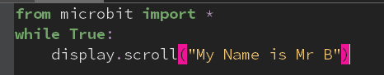

A. Show string

B. Show LEDs

C. Show icon

D. Set display mode black and white

ANSWER: A

What is ‘event driven programming’?

A. Where the outcome of a function depends only on the arguments that are passed to it

B. Where actions control the flow of the program

C. Where code always runs in order, step by step

D. Where code is written using only block programming

ANSWER: B

Which of the commands below creates a function?

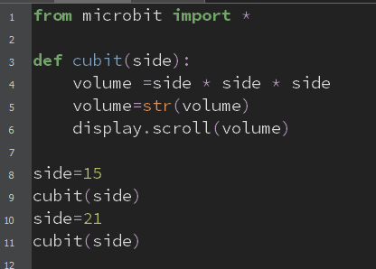

A. from

B. def

C. str

D. import

ANSWER: B

What is GPS used for?

A. To identify location

B. To identify noise levels

C. To identify power levels in batteries

D. Where code is written using only block programming

ANSWER: B

The technology adoption cycle can be used to determine when different groups are likely to purchase a product. Which group is likely to purchase the product when it is first launched?

A. Laggards

B. Early majority

C. Late majority

D. Early adopters

ANSWER: D

The technology lifecycle defines different stages in the life of a product. During which stage will use of the product become the norm?

A. Growth

B. Research and Development

C. Maturity

D. Decline

ANSWER: C

Which sensor would you use with the code below?

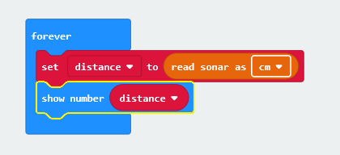

A. Light

B. Ultrasonic

C. Accelerometer

D. Thermometer

ANSWER: B

What is machine learning?

A. When you program a machine to do something

B. When a human teaches a robot to do something

C. When a machine learns for itself and adapts to different situations

D. A type of machine which a human learns from

ANSWER: C

SWOT analysis can be used to analyse the potential success of a product. What does W stand for in SWOT analysis?

A. Web

B. Weaknesses

C. Wires

D. Wearable

ANSWER: B

What does an ultrasonic sensor use to measure distance?

A. Radio waves

B. Light waves

C. High frequency sound

D. Touch

ANSWER: C

Which of the following contains an embedded system?

A. Washing machine

B. Sat Nav

C. Video doorbell

D. All of the above

ANSWER: D

When writing code in Python you can create functions. What is a function?

A. A type of iteration

B. A type of selection

C. A way of creating reusable sections of code

D. A type of sequence

ANSWER: C